Q1)

Include Irvine32.inc

.data

count DWORD 1

.code

main PROC

mov ecx,0

mov ecx,20

L1:

mov edx,ecx

mov ecx,count

L2:

mov eax," "

call writechar

loop L2

mov ecx,edx

inc count

mov eax,990

call randomize

call randomrange

call writeint

call crlf

call delay

loop L1

exit

main ENDP

END main

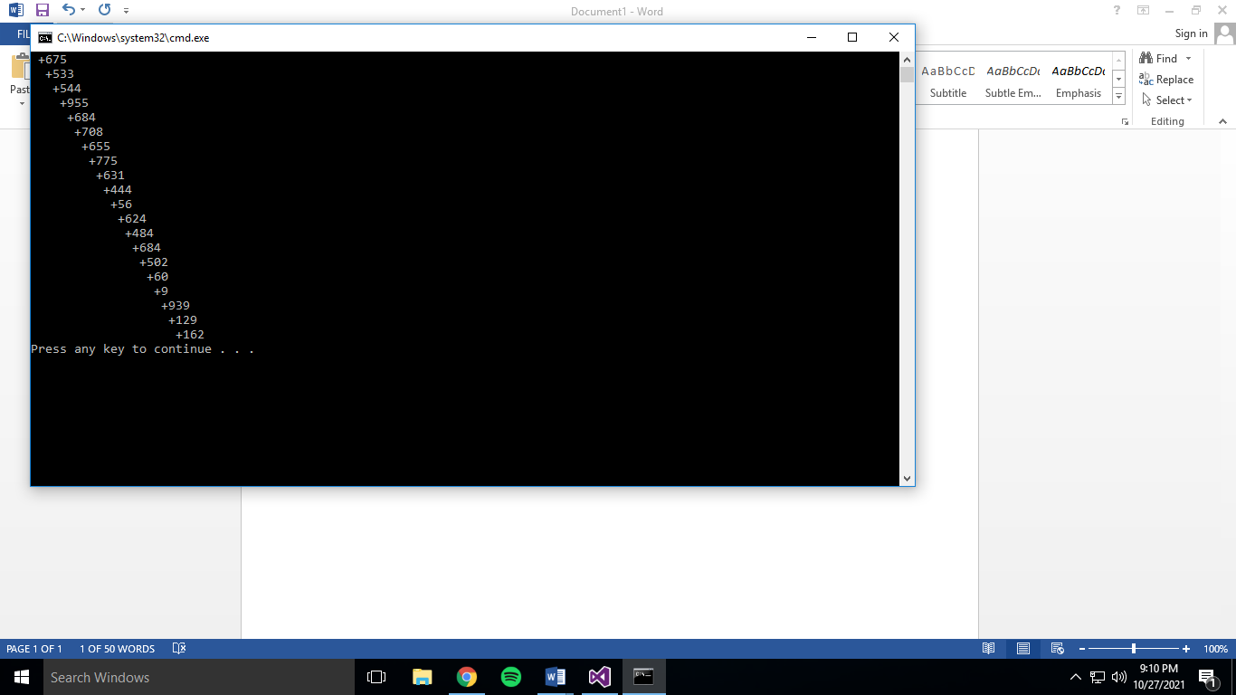

Q2)

Include Irvine32.inc

.data

decimal DWORD 1

.code

main PROC

mov eax,0

mov ecx,0

mov ecx,100

L1:

mov eax,100

call randomize

call randomrange

mov ebx,eax

mov ax,bx

mov dx,bx

call GetMaxXY

mov eax,"\*"

call writechar

mov eax,decimal

call delay

loop L1

exit

main ENDP

END main

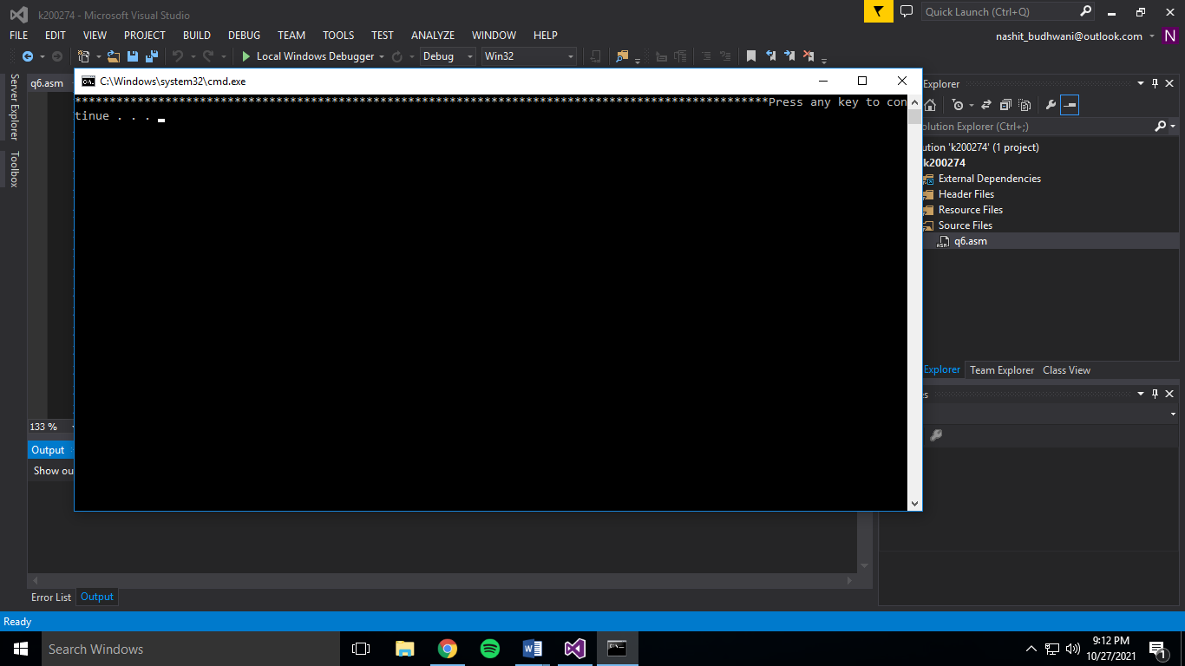

Q3)

Include Irvine32.inc

.data

arr2 byte "Signed Numbers: "

a word 0

arr1 byte "Unsigned Numbers: "

.code

main PROC

mov eax,0

mov ecx,0

mov ecx,10

mov edx,OFFSET arr1

call writestring

call crlf

L1:

mov eax,294d

call randomize

call randomrange

call writedec

call crlf

loop L1

mov edx,OFFSET arr2

call writestring

call crlf

mov ecx,0

mov ecx,10

L2:

mov eax,+49

call randomize

call randomrange

call writeint

call crlf

loop L2

exit

main ENDP

END main

